**mOTP Spam Blocker**

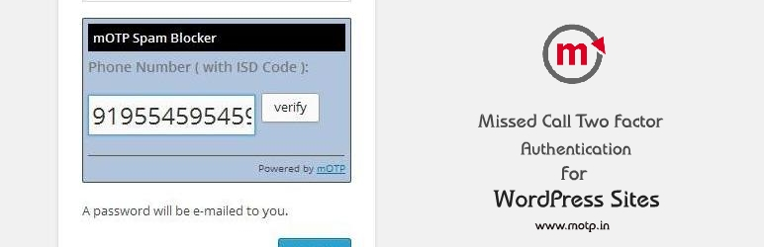

**Introduction:**

Plugin for implementing two factor authentication with missed calls. Verification can be set on various screens as per users choice.

**Description:**

mOTP Spam Blocker plugin helps you to protect your website with spam users and at the same time it builds trusted user-base by verifying user phone numbers mOTP Project was launched in late 2012 to revolutionize the two factor authentication process by adopting cost effective missed call based OTP sending. ( Ref: <http://mOTP.in> )

**Features:**

▪ No Changes required to the WordPress Code   
▪ Can be integrated easily on,  
 Login Page   
 Register Page   
 Lost Password Page   
 Comments Page  
  
▪ Define Maximum retries per IP   
▪ Define Time between re-trials   
▪ IP Blacklisting   
▪ Phone Number Blacklisting

**Installation:**

1. Upload plugin folder to the /wp-content/plugins/ directory
2. Activate the plugin through the 'Plugins' menu in WordPress
3. Open a free account at mOTP.in to get free API Public key and Private keys
4. Configure your plugin accordingly from wordpress (mOTP Plugin menu )

**Screen shots:**

1. [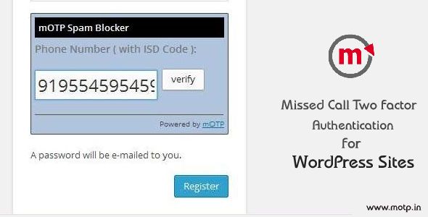](https://s.w.org/plugins/two-factor-authentication-with-missed-calls-spam-blocker/screenshot-1.png?r=1035356)

Intro

1. [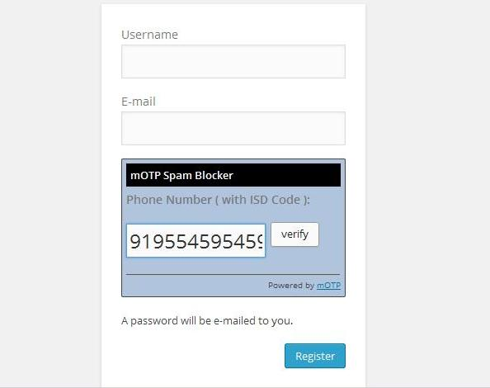](https://s.w.org/plugins/two-factor-authentication-with-missed-calls-spam-blocker/screenshot-2.jpg?r=1035356)

Signup screen preview

1. [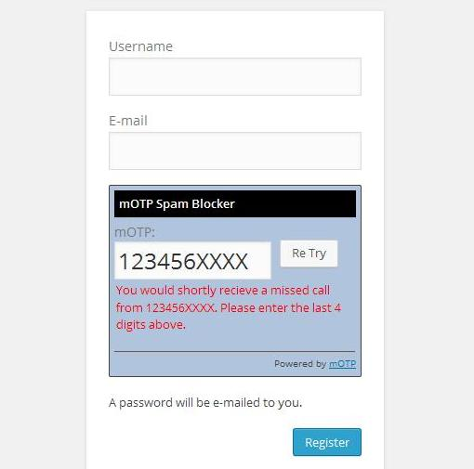](https://s.w.org/plugins/two-factor-authentication-with-missed-calls-spam-blocker/screenshot-3.jpg?r=1035356)

Signup verification screen preview

1. [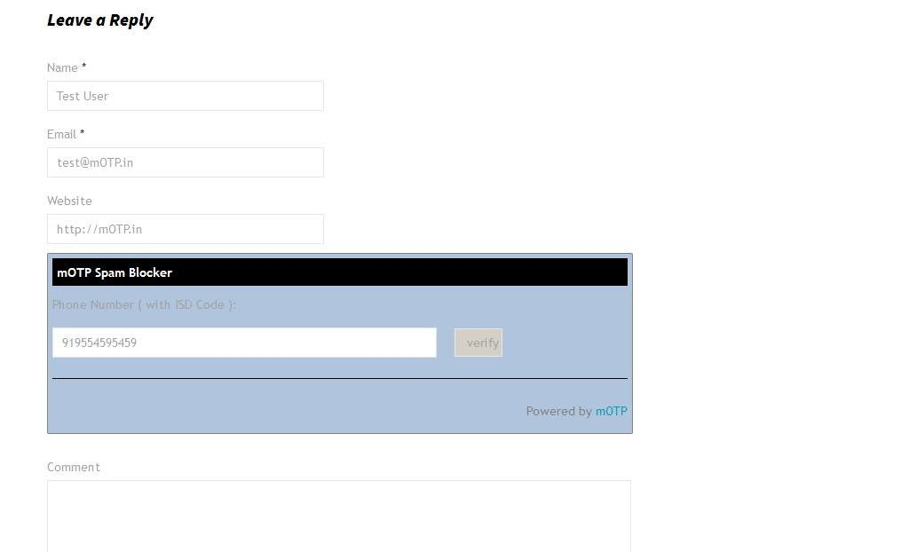](https://s.w.org/plugins/two-factor-authentication-with-missed-calls-spam-blocker/screenshot-4.jpg?r=1035356)

Comments section

1. [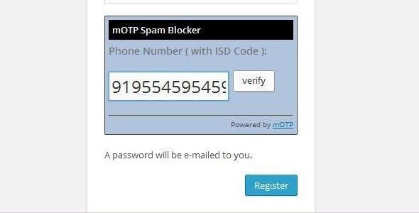](https://s.w.org/plugins/two-factor-authentication-with-missed-calls-spam-blocker/screenshot-5.jpg?r=1035356)

Misc

1. [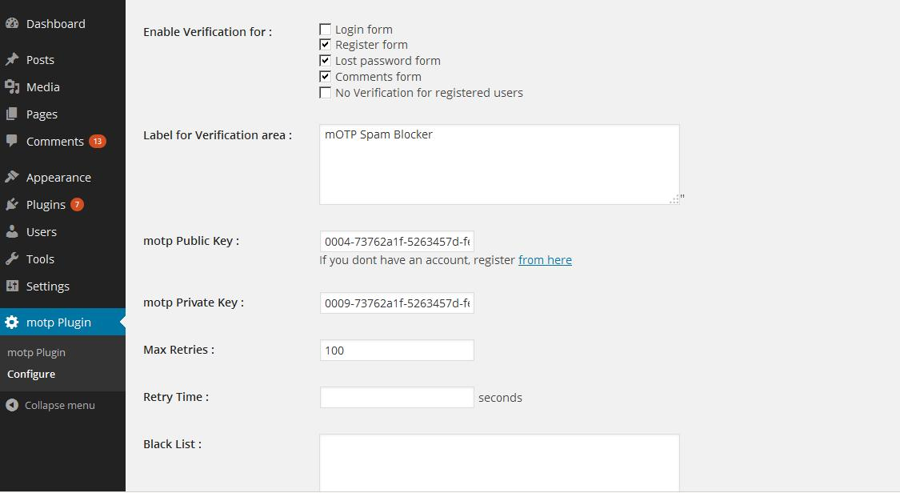](https://s.w.org/plugins/two-factor-authentication-with-missed-calls-spam-blocker/screenshot-6.jpg?r=1035356)

Admin panel